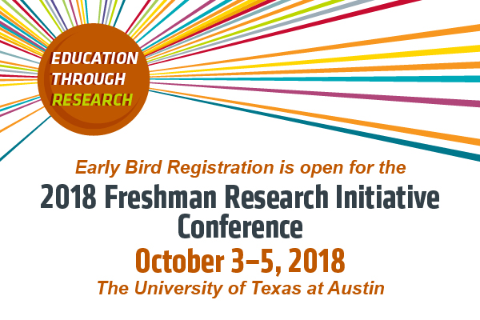
REGISTER HERE

The Freshman Research Initiative (FRI) was launched in 2005 to unite the dual missions of research and teaching at The University of Texas at Austin. FRI involves first-year students as collaborators on original research as an alternative to entry-level laboratory courses. The program is now a national model for transforming undergraduate STEM education by offering undergraduate research experiences to roughly 1,000 new students each year. Participation in FRI improves undergraduates’ chances of graduating and earning a STEM degree (Rodenbusch, Hernandez, Simmons, & Dolan, 2016).

The 2018 FRI Conference is designed to engage and support faculty and administrators who are interested in adapting the FRI educational model at their own institutions. This year we will provide sessions tailored to help attendees develop and implement the FRI model in two concurrent sessions. The faculty sessions will focus on developing course curricula and research programs to meet educational and research goals. Meanwhile, the administrator sessions will address how to develop an FRI-like program that meets institutional goals, fits into the undergraduate curriculum, and is financially sustainable. We ask conference applicants to attend as a team of at least two people from their institution to get the most out of the conference by allowing participation in both the faculty and administration sessions.

The conference will feature presentations and interactive sessions including the following themes:
· Funding and Sustainability
· Generating Faculty and Administrator Buy-in
· Course Development and Curricular Integration
· Instructional Staff Recruitment and Training

All sessions will provide information on the diverse ways that the FRI model has been implemented at other institutions as well as a focus on how to overcome key barriers.

Information about registration, accommodations and a tentative agenda are posted on the conference website. Feel free to contact Jo-anne Holley, Conference Organizer, at jo.holley@utexas.edu with any questions. We hope you will join us in October!

Thank you,

The Conference Steering Committee

Sarah Eichhorn, The University of Texas at Austin
Stacia Rodenbusch, The University of Texas at Austin
Patrick Killion, The University of Maryland College Park
Megan Fegley, Binghamton University - SUNY
Nancy Stamp Binghamton University - SUNY

Conference Organizer
Jo-anne Holley, The University of Texas at Austin

